**Build and Release Management**

**Lab-4**

Date: 11-02-21

Name: RAJUL DUBEY

SAP ID: 500069424

ROLLNo.: R171218081

**Task.1->** Build Maven Project with Jenkins and Git Hub

**Task.2->** Make Builds automatically

Lab Practice:

1.) Run Jenkins in cmd(as Administrative)

**Command:**

java –jar Jenkins.war

2.) Goto web browser and goto **localhost:8080/**

3.) Login to jenkins and Create a job

4.) Give name as: BRM_LAB4_2021

Note1: If there’s no “Maven Project” option is available try to download maven plugin

Jenkins (**manage jenkins->manage plugins->maven integration**)

5.) Options:

i.) JIRA SITE PROJECT

* Git Project

Note2: If there’s no JIRA SITE PROJECT option **Install the Jira Cloud**

**plugin for Jenkin (Atlassian Jira Software Cloud) *reference Note1***

ii.) Source Code Management

* Git

iii.) Build Triggers

Will use in Task.2

iv.) Build

* root POM -> pom.xml
* Goals and Options -> **clean** (or any other goal)

v.) Apply and Save

vi.) Click on -> *Build Now*

Note3: If error comes “ERROR: A Maven installation needs to be available…”

Goto -><https://plugins.jenkins.io/maven-plugin/>

*vi.) Configure Maven,Git and JDK paths in

Manage Jenkins-> Global Tool Configuration

Console Output

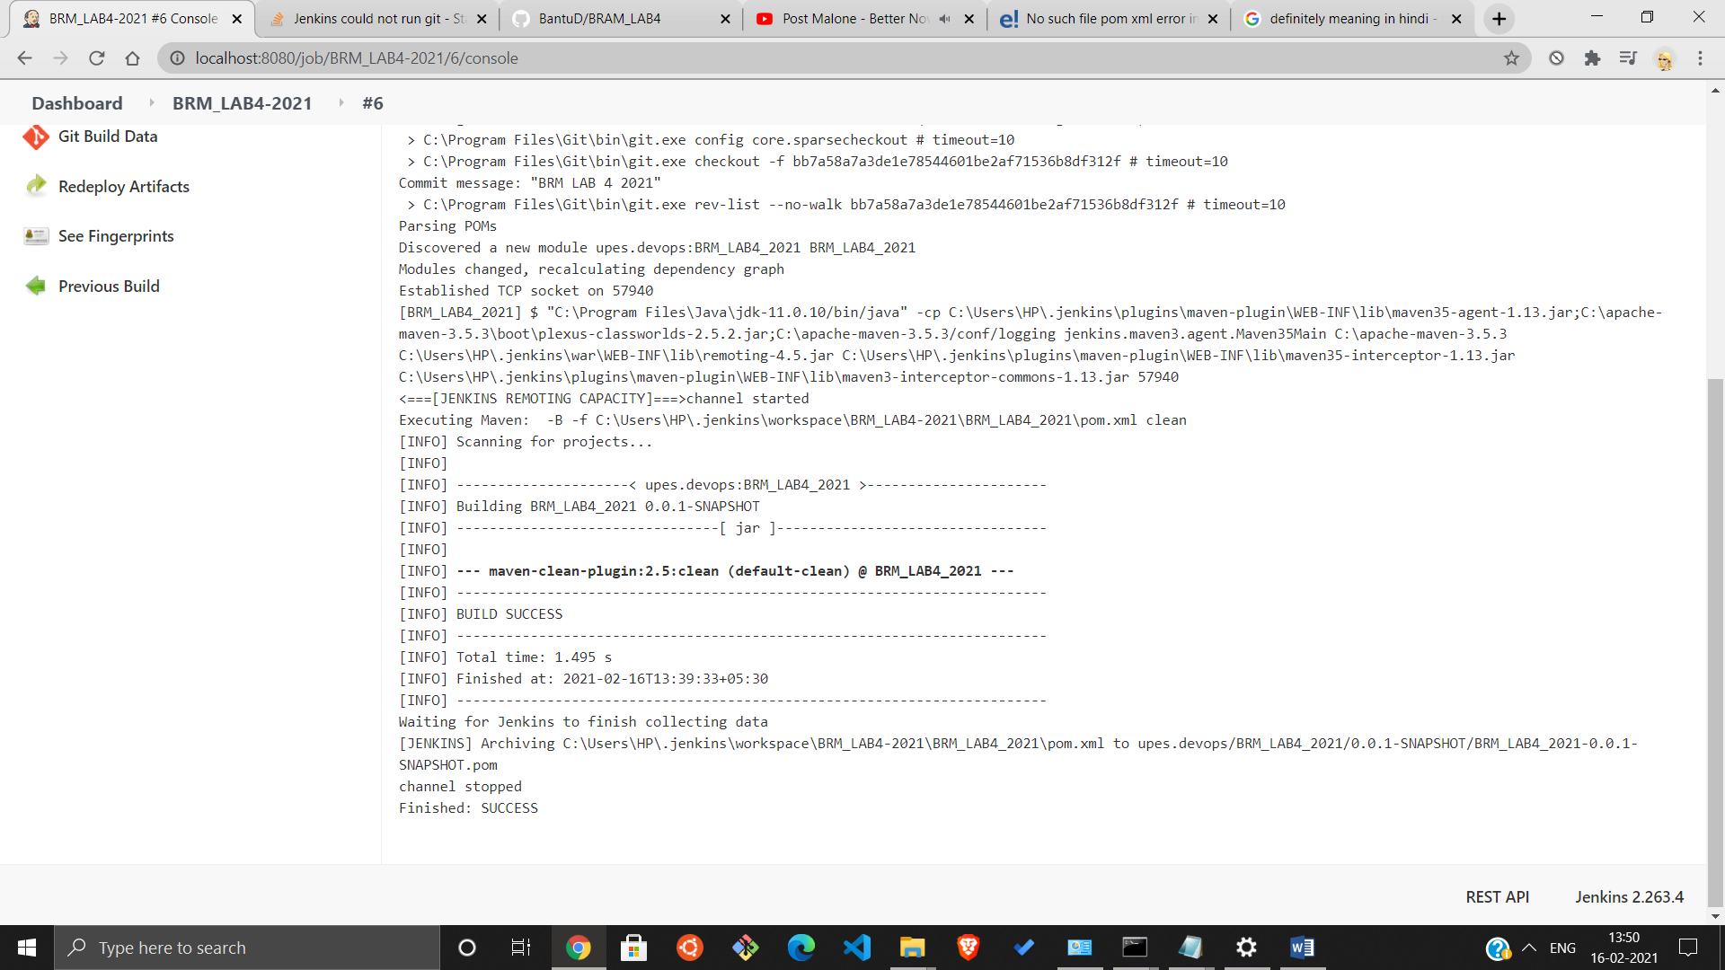



Now build automatically.

i.) goto: Job->configuration and mark checked pollSCM

ii.) Click on (?) to see option about it or you can just put

5 stars separated with spaces Like: * * * * *

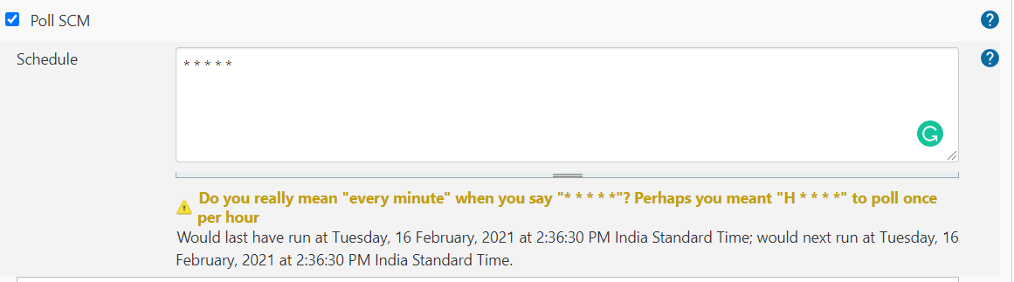

It means build will run automatically every min after you start it for the first build

iii.) Now push changes to github through eclipse and builds will automatically get done

